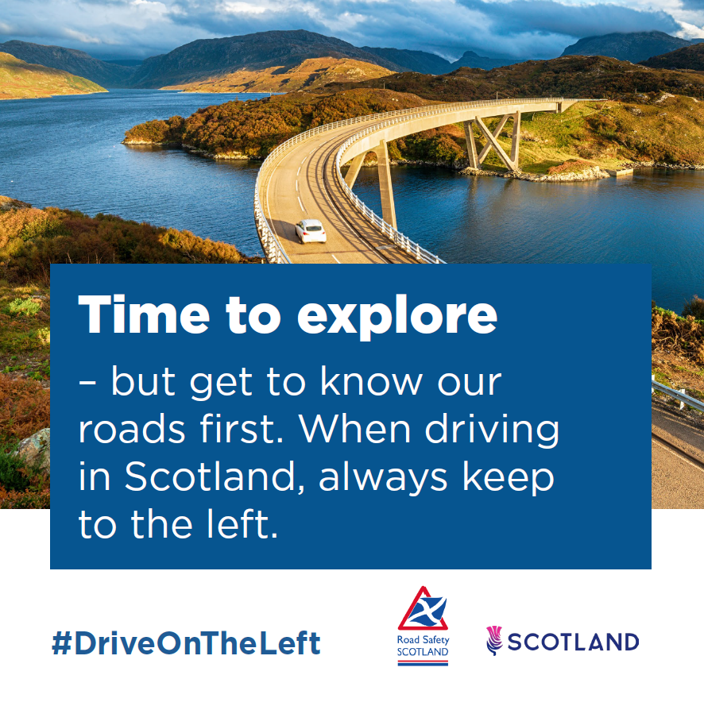
A scenic landscape. The caption reads: ‘Time to explore – but get to know our roads first. When driving in Scotland, always keep to the left.’

