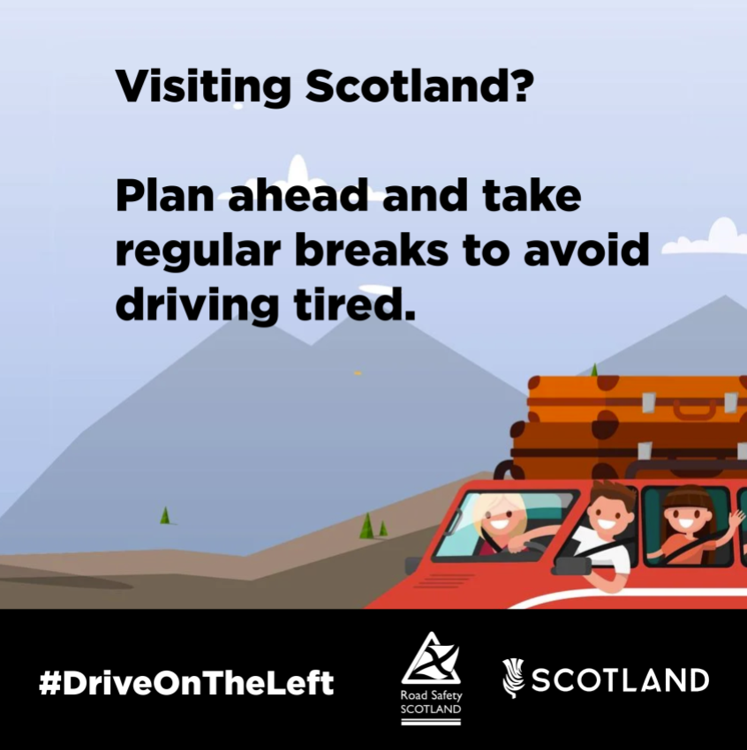
A family driving in a scenic landscape. The caption reads: ‘Visiting Scotland? Plan ahead and take regular breaks to avoid driving tired.’

