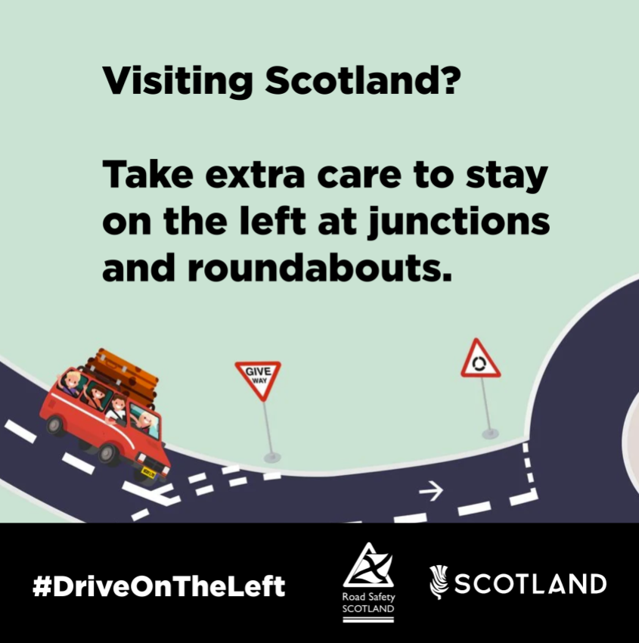
A family in a car approaching a roundabout. Caption reads: ‘Visiting Scotland? Take extra care to stay on the left at junctions and roundabouts.’

