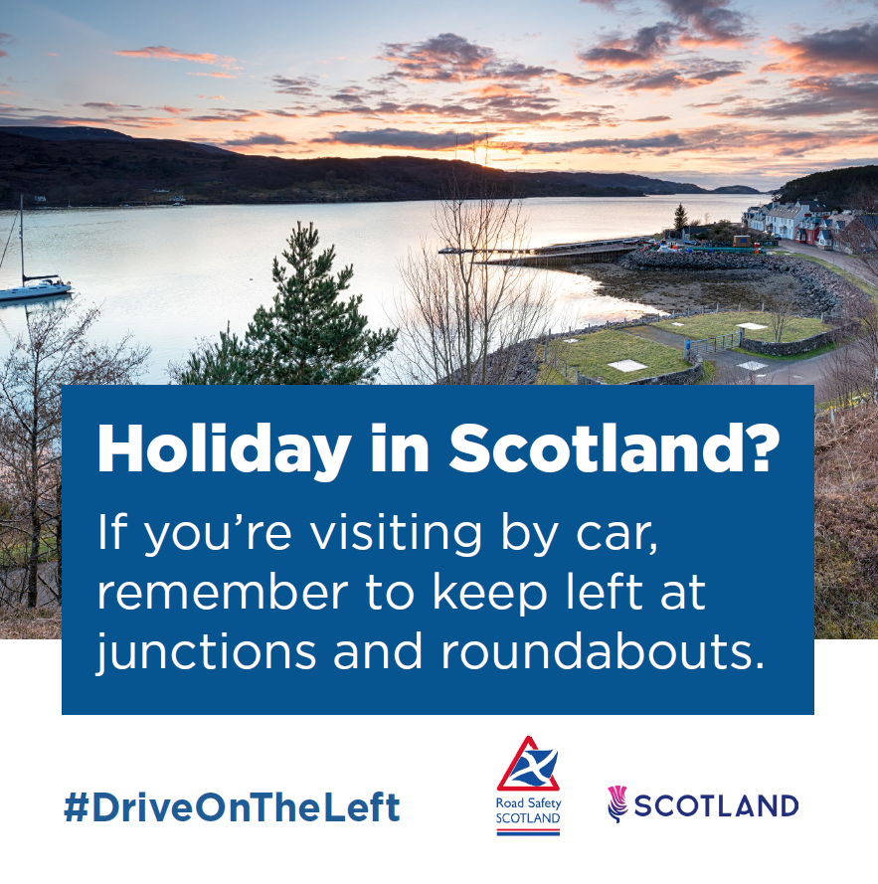
A loch at sunset. The caption reads: ‘Holiday in Scotland? If you’re visiting by car, remember to keep left at junctions and roundabouts.’

