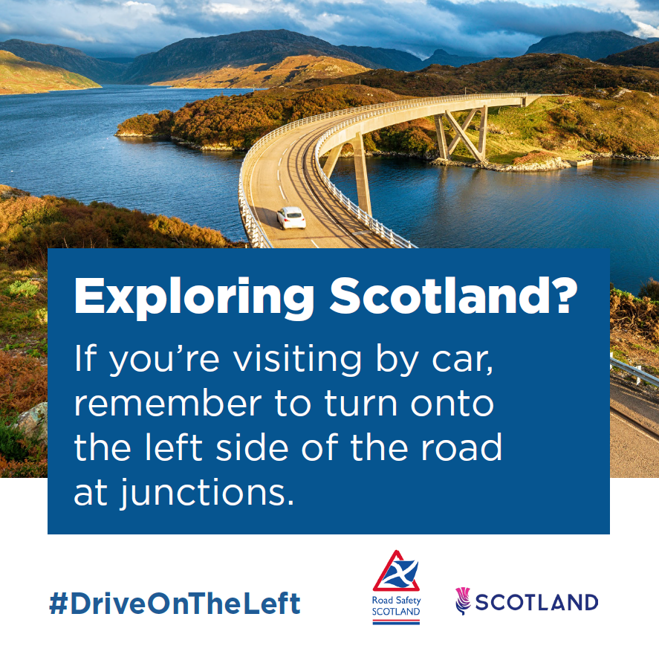
A scenic landscape. The caption reads: ‘Exploring Scotland? If you’re visiting by car, remember to turn onto the left side of the road at junctions.’

