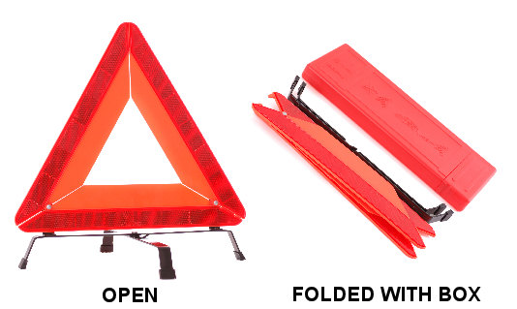
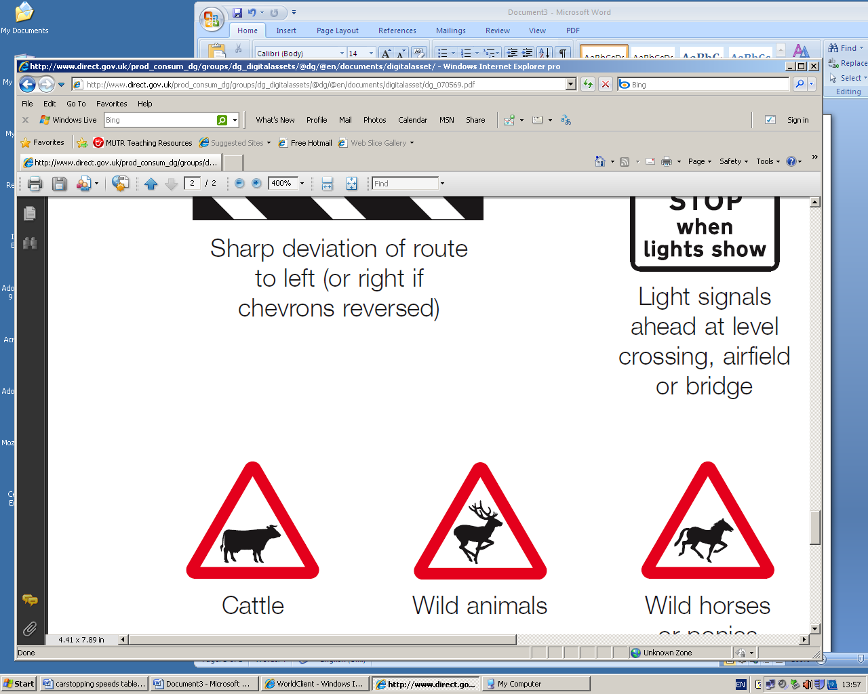
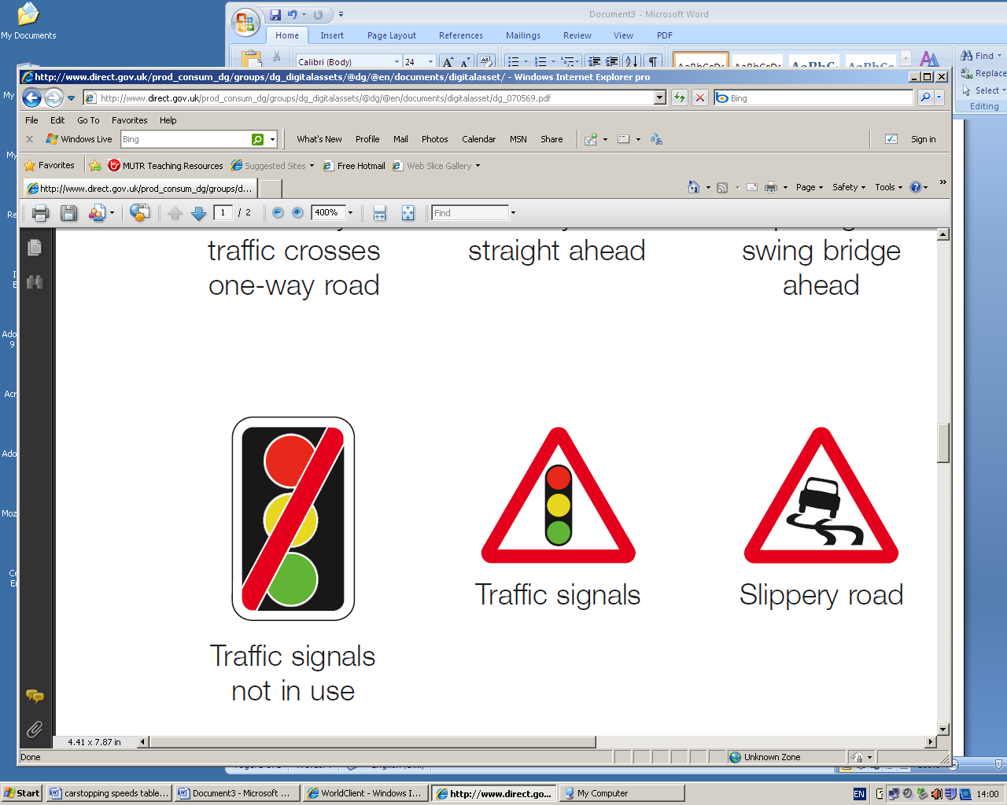
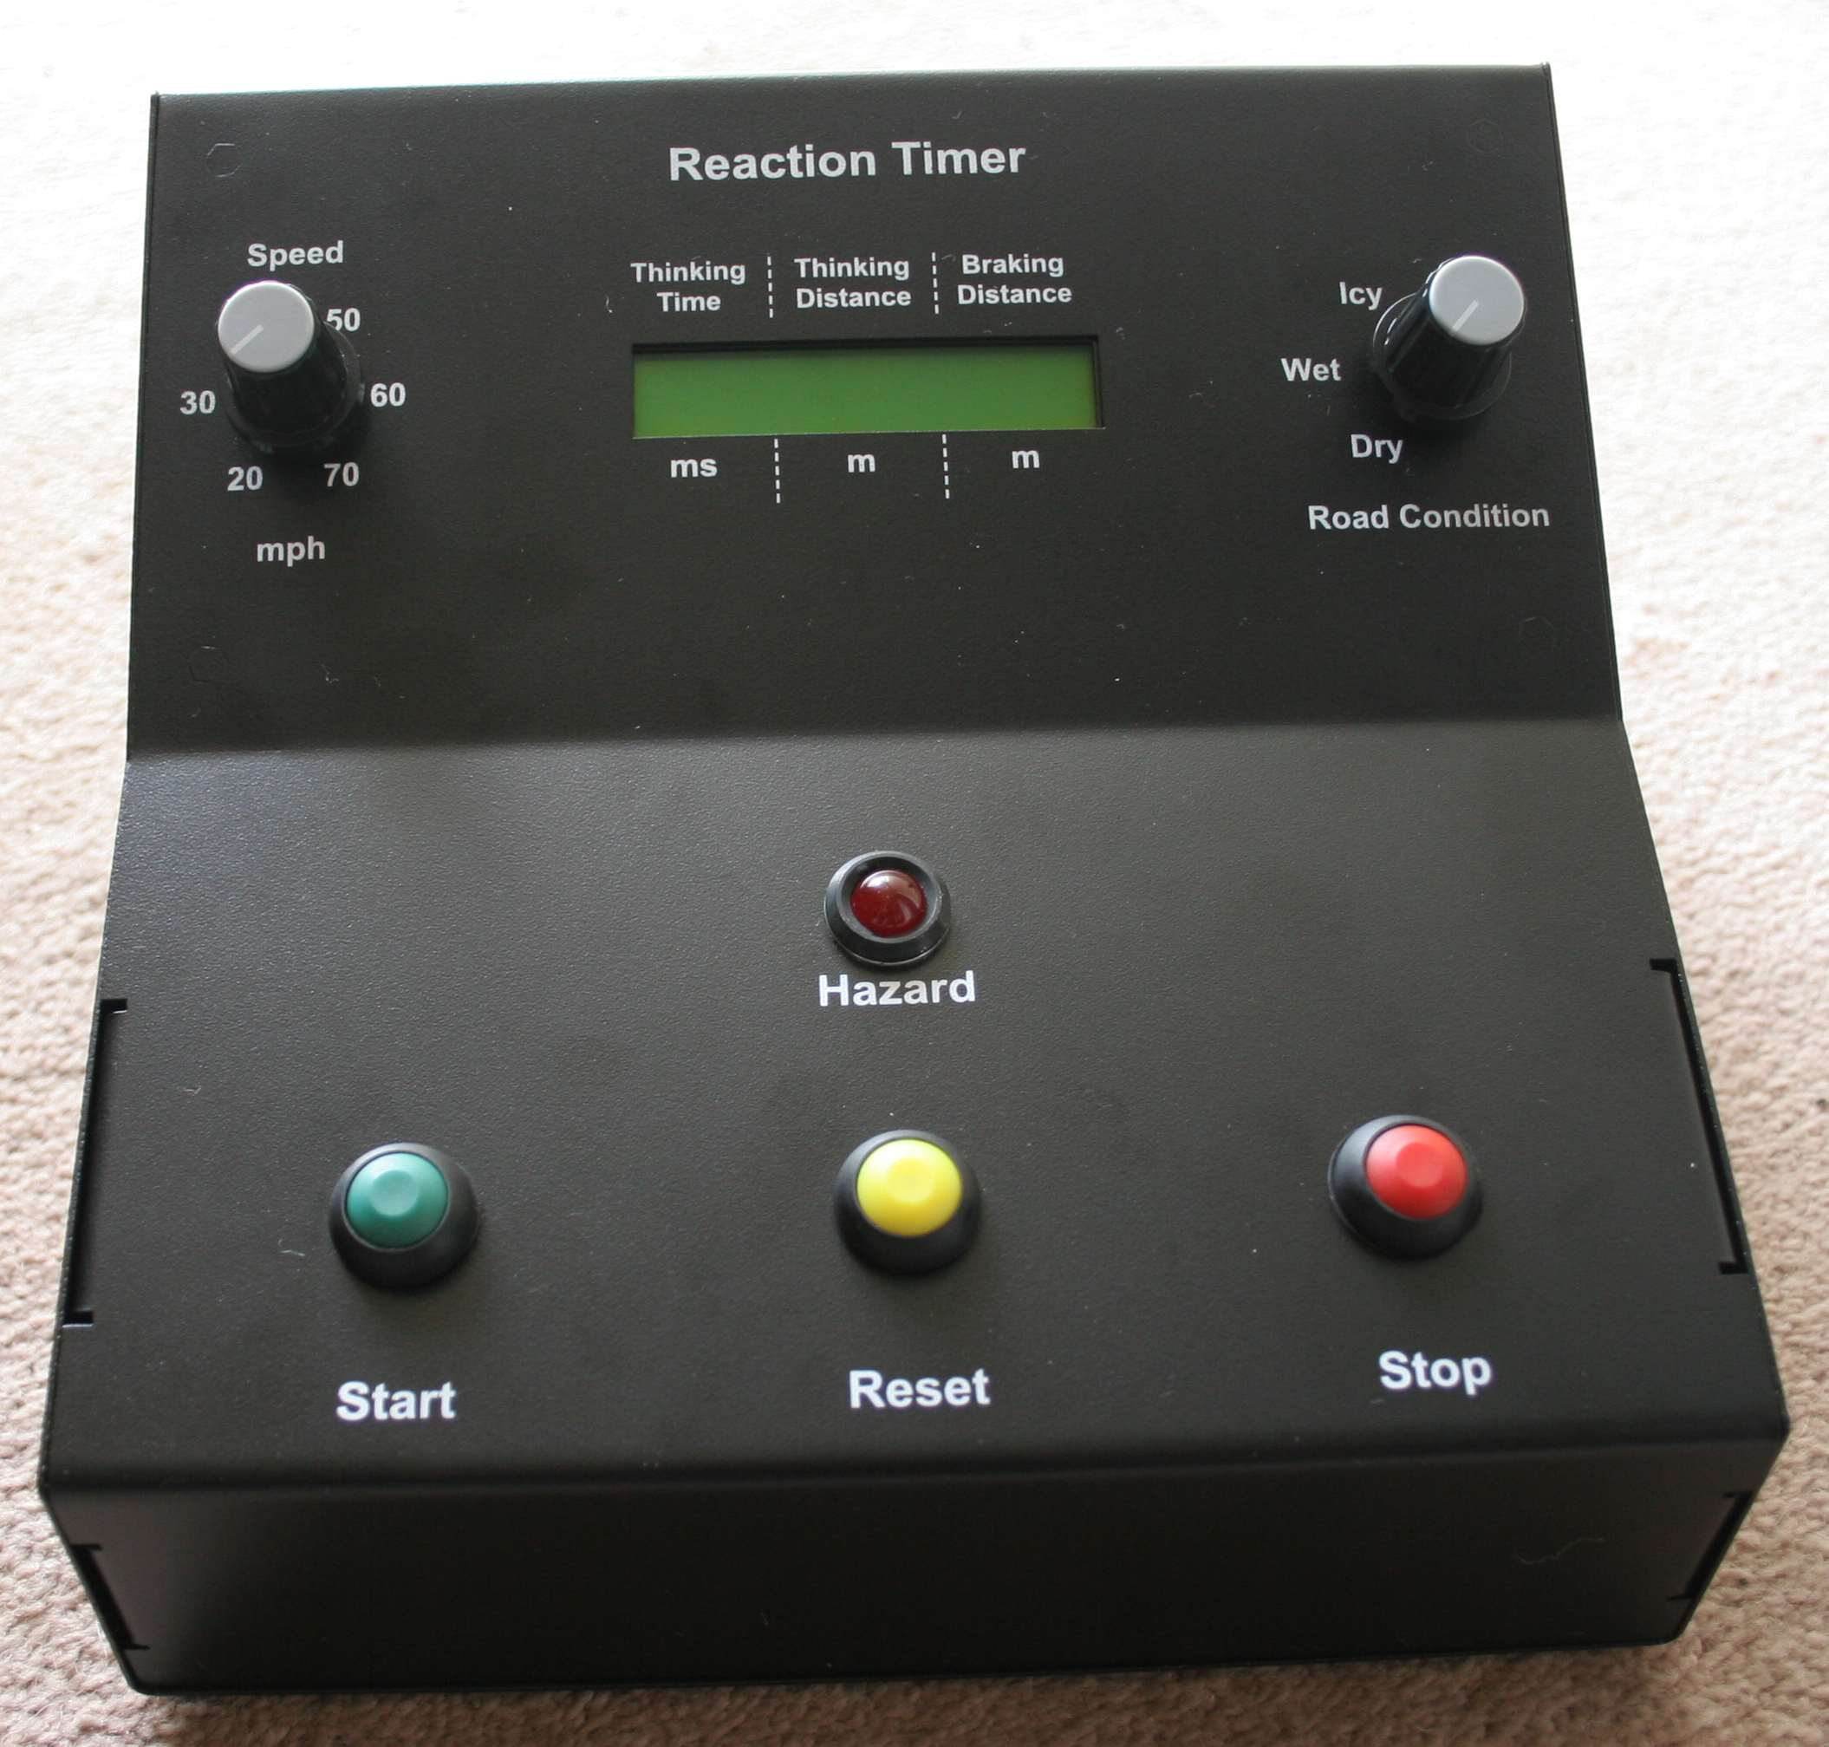
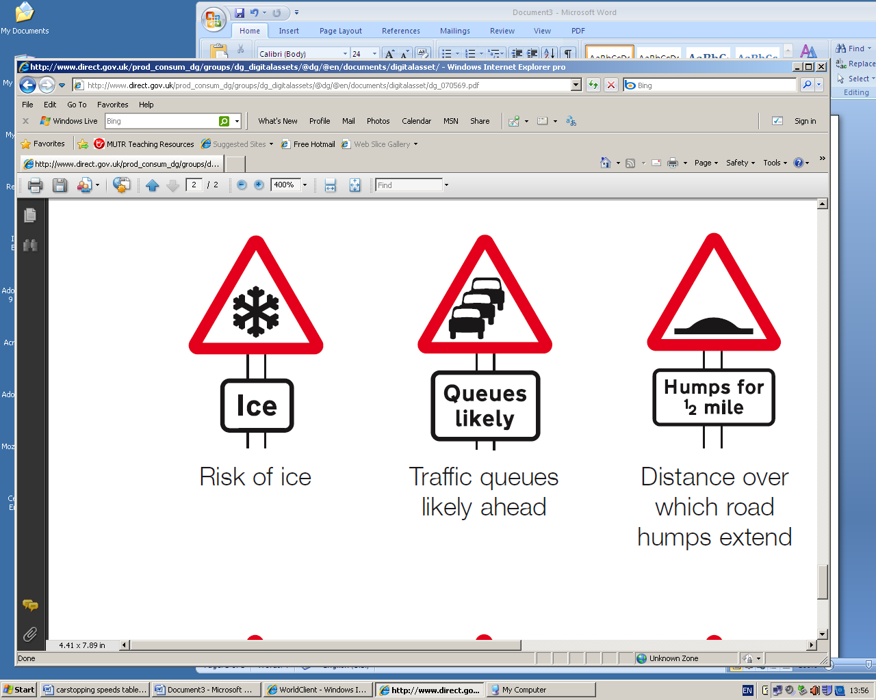
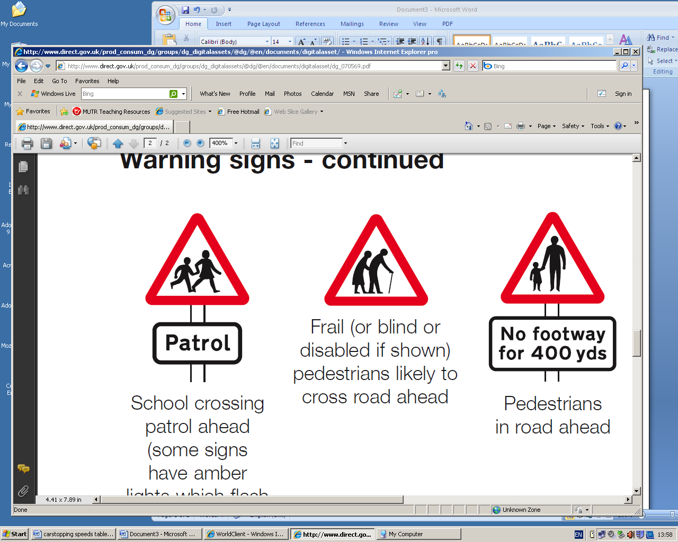

You need to know:
Stopping distance = thinking distance + braking distance

Do this:
- Set the speed dial to 20 mph
- Set the road conditions to dry
- Press the yellow Reset button
- Press the green Start button.
- The hazard light will start to flash. When it stops flashing, press the red Stop button.
- Record your thinking time, thinking distance and braking distance.
- Work out your stopping distance.

